

**Christmas Menu:**

Spiced Apple and Parsnip Soup (v)

Wild Mushroom Ravioli – Hazel Nuts - Roasted Garlic Oil (v)

Beetroot Cured Salmon – Horseradish Cream

Roast Turkey – Cranberry Sauce – Chipolata Sausage – Game Chips

Roast Top Side Beef – Horseradish Cream – Yorkshire Pudding

Roast Loin of Pork – Apple Sauce – Sage and Onion Stuffing

Roasted Chestnut and Red Onion Tartlet – Cranberry Sauce – Rocket (v)

Roasted Potatoes - Brussel Sprouts – Roasted Root Veg

Christmas Pudding - Rum Sauce

Lemon Citrus Tart – Berry Sauce

Mulled Wine Poached Pear – Pink Peppercorn Shortbread

Coffee and Mince Pies

*5 courses for £18*

[](http://www.hospitalityguild.co.uk/Training-Development/Best-practice/Accreditation/Find-an-accredited-provider) [](http://explorebuxtonderbyshire.co.uk/best-western-leewood-hotel/429375_367773053257098_1452315956_n/) [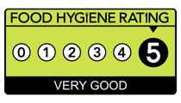](http://www.google.co.uk/url?sa=i&rct=j&q=&esrc=s&source=images&cd=&cad=rja&uact=8&ved=0ahUKEwiIrtqZgMjLAhWKvBQKHVDICRMQjRwIBw&url=http://www.cricketers-arms.co.uk/cricketers-arms-news&psig=AFQjCNEX8r1b-Hes4F5fAhc_u5AiYndkVQ&ust=1458313749213268) [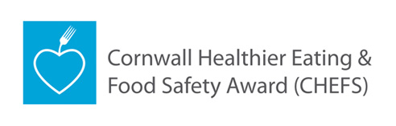](http://www.google.co.uk/url?sa=i&rct=j&q=&esrc=s&source=images&cd=&cad=rja&uact=8&ved=0ahUKEwiGttStgcjLAhXD1xQKHYwIDn0QjRwIBw&url=http://www.cornwall.gov.uk/chefs&psig=AFQjCNFJ7mLFMo8RJ_4lzzzHvGSJMBBV6Q&ust=1458313955458058) [](https://www.google.co.uk/url?sa=i&rct=j&q=&esrc=s&source=images&cd=&ved=0ahUKEwjGpKDhg8jLAhULuBQKHR6YDbsQjRwIBw&url=https://www.cornwall.ac.uk/trevenson-restaurant&psig=AFQjCNFbH9foWDYtjderBkIAanPnn8_9bQ&ust=1458314703213235)